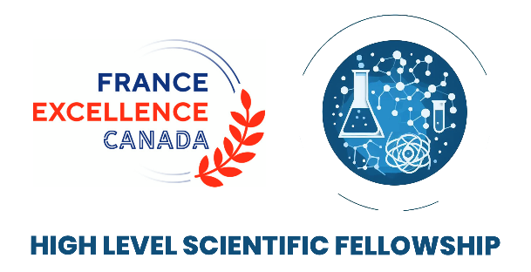

2024 APPLICATION FORM
HIGH LEVEL SCIENTIST FELLOWSHIP

Applicant personal information
First name: Last name:
Email:
Name of the institution:
Name of the research unit’s Director/Head:
Mailing address:
Postal code: City:
Website:
Host Research Unit information
First name Last name:
Email:
Name of the host:
Name of the host’s research unit (Centre, Department, Institute or School):
Name of the research unit’s Director/Head:
Mailing address:
Postal code: City:
Website:
Research Project
Field of Research:
Advanced Sciences (AI, quantum, societal impact, etc.)
Health (one health, public health policy, genomics, etc.)
Ocean and polar sciences (oceanography, biodiversity, marine ecology, etc.)
Energy (renewable energy, net zero transition, sustainability, etc.)

Please check this box if your project is interdisciplinary

Title of the Project:

Description of the project (300 words +/- 50 words):

Explain how the applicant and the host research partner may each expect to benefit from the program (300 words +/- 50 words):

Biographies of the researchers
Short biography of the applicant (300 words +/- 50 words):

Other information
Abstract of the project, written for the general public: 150 words +/- 50 words

Mandatory Attached documents:
Cover letter from the applicant
Letter of support from your PhD or post-doc supervisor
Invitation letter from the host research unit, signed by both the research host and the unit director/head, and including details on the access to space, equipment and resources that will be provided to the successful applicant
Applicant’s short CV (700 words)
A copy of your passport

Please be advised that if you are selected, you will have to provide an activity report within a month following the completion of your residency.

